# Manual Ice Racer

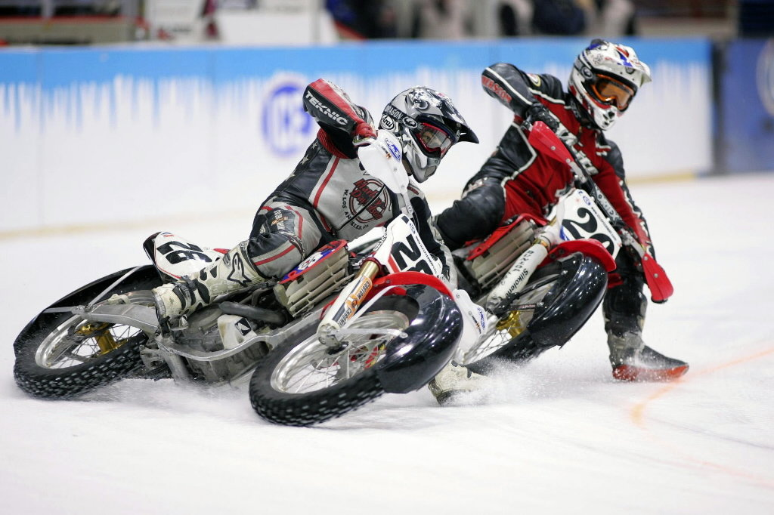

# Introduction

This is the manual for our game: “Ice Racer”! It’s an easy to use game that aims for you to beat your personal time records on our track!

## Movement

Movement in our game is done with the WASD keys, W for forward, A for left, D for right and S for backwards

## Scoring

Your performance is rated by a time on the top of the screen that will stop once you complete the lap, compare your score with your friends and try to beat their best scores!

## Obstacles

Dodge the obstacles on the course, hitting an obstacle will slow you down and affect your high score

## Stay on the Track!

Try to stay on the track, as there’s nothing to race on besides the track! When you do fall don’t worry, the game will catch you and put you back on the track, but the time keeps ticking….